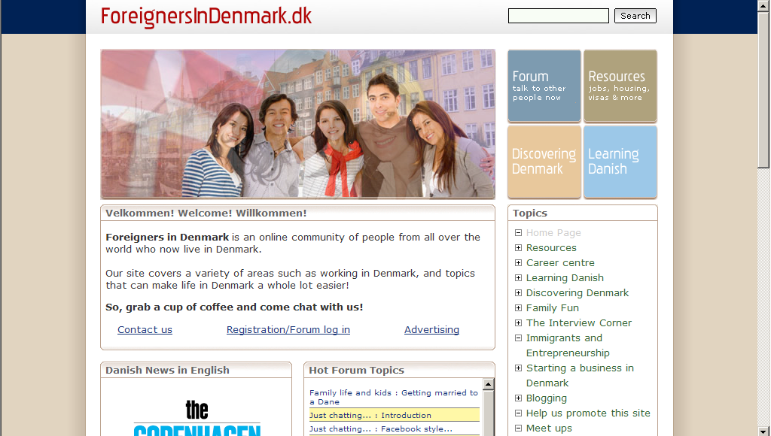
About Us
Home/ Contact us/contact #
Work Permit
Study
Abroad
Testimonials
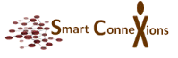
We focus on spirited….

Some of us have spent large amounts of time and money on a search for RIGHT connection; some have needed only the information contained in their own approach; some have concluded the search is fruitless and a waste of time. All are welcome here.

SmartConnexions is one of the foremost companies that provide Immigration and Settlement solutions – with a Human Touch to the people who wishes to migrate to other country and make Fortune.

A blend of all-embracing experience, global presence and surrounded by industry knowledge enables us to provide solutions that deliver results. SmartConnexions promises to endow with one stop solution to the people interested to resettle, work, study, invest and do business in few of the most favored countries like UK, Denmark, New Zealand, Australia, Canada, and USA.

We leverage deep industry and functional expertise, leading practices, and an advanced, global delivery model to help clients transform their dreams and desires.

SmartConnexions is a creation of values and ethics. Customization is our approach and our employees reflect our commitment. SmartConnexions has a supreme team of immigration experts who have the latest knowledge on Immigration Cycle and well equipped information on predictable changes. This expertise in the industry gives a trailblazer making SmartConnexions a clear-cut eminence in the Global Resettlement industry.
Why SmartConnexions?

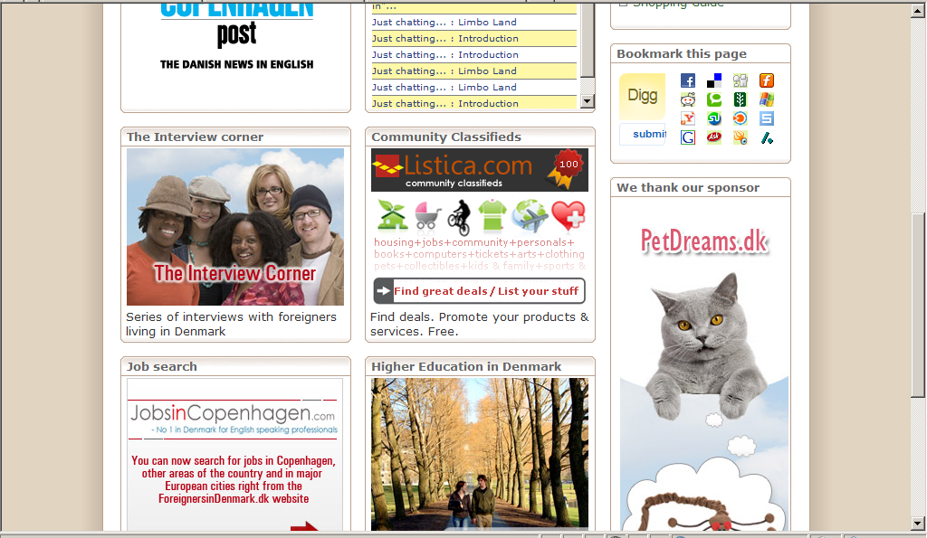
Industry Updates

